WEEK-8 LAB-A

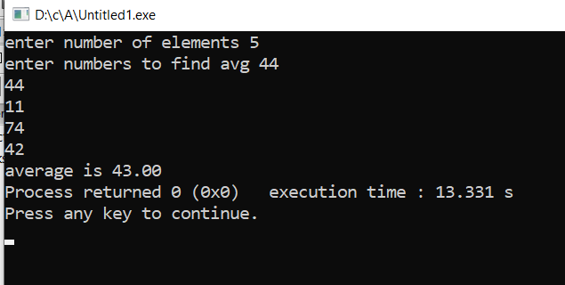Q1. #include<stdio.h>

#include<stdlib.h>

int main()

{

int n,a[100],sum=0;

printf("enter number of elements ");

scanf("%d",&n);

printf("enter numbers to find avg ");

for(int i=0;i<n;i++)

{

scanf("%d",&a[i]);

sum+=a[i];

}

printf("average is %0.2f",(float)sum/n);

}

Q2. #include <stdio.h>

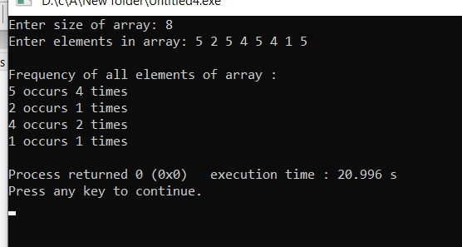

int main()

{

int arr[50], freq[50];

int size, i, j, count;

printf("Enter size of array: ");

scanf("%d", &size);

printf("Enter elements in array: ");

for(i=0; i<size; i++)

{

scanf("%d", &arr[i]);

freq[i] = -1;

}

for(i=0; i<size; i++)

{

count = 1;

for(j=i+1; j<size; j++)

{

if(arr[i]==arr[j])

{

count++;

freq[j] = 0;

}

}

if(freq[i] != 0)

{

freq[i] = count;

}

}

printf("\nFrequency of all elements of array : \n");

for(i=0; i<size; i++)

{

if(freq[i] != 0)

{

printf("%d occurs %d times\n", arr[i], freq[i]);

}

}

}

Q3. #include<stdio.h>

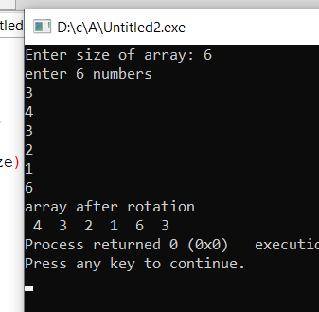int main()

{

int a[10],temp;

printf("enter 10 numbers \n");

for (int i=0;i<10;i++)

{

scanf("%d",&a[i]);

}

temp=a[0];

for (int i=0;i<9;i++)

{

a[i]=a[i+1];

}

a[9]=temp;

printf("array after rotation \n");

for (int i=0;i<10;i++)

{

printf(" %d ",a[i]);

}

}

Q4. #include<stdio.h>

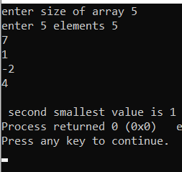int main()

{

int n,a[100],temp;

printf("enter size of array ");

scanf("%d",&n);

printf("enter %d elements ",n);

for(int i=0;i<n;i++)

{

scanf("%d",&a[i]);

}

for ( int i = 0; i < n-1; i++)

{

for (int j = 0; j < n-i-1; j++)

if (a[j] > a[j+1])

{

temp=a[j];

a[j]=a[j+1];

a[j+1]=temp;

}

}

printf("\n second smallest value is %d ",a[1]);

}

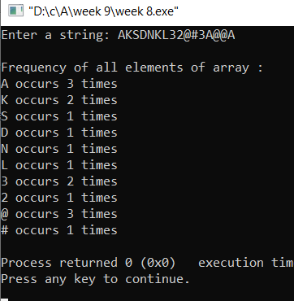Q5. #include<stdio.h>

#include<stdlib.h>

int main()

{

int freq[50],i, j, count;

char arr[50];

printf("Enter a string: ");

gets(arr);

i=0;

while(arr[i]!='\0')

{

freq[i] = -1;

i++;

}

i=0;

while(arr[i]!='\0')

{

count = 1;

j=i+1;

while(arr[j]!='\0')

{

if(arr[i]==arr[j])

{

count++;

freq[j] = 0;

}

j++;

}

if(freq[i] != 0)

{

freq[i] = count;

}

i++;

}

printf("\nFrequency of all elements of array : \n");

i=0;

while(arr[i]!='\0')

{

if(freq[i] != 0)

{

printf("%c occurs %d times\n", arr[i], freq[i]);

}

i++;

}

}

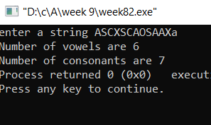Q6. #include<stdio.h>

int main()

{

char arr[20];

int i=0,V=0,C=0;

printf("enter a string ");

gets(arr);

while(arr[i]!='\0')

{

if((arr[i]>64 && arr[i]<91)||(arr[i]>96 && arr[i]<123))

{

if(arr[i]=='a' || arr[i]=='e' || arr[i]=='i' || arr[i]=='o' || arr[i]=='u' || arr[i]=='A' || arr[i]=='E' || arr[i]=='I' || arr[i]=='O' || arr[i]=='U')

V++;

else C++;

}

i++;

}

printf("Number of vowels are %d \n",V);

printf("Number of consonants are %d",C);

}